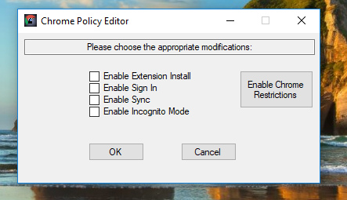

Chrome Policy Editor User Instruction Manual:

The Chrome Policy Editor application comes in the form of a .exe file. After downloading and then running the application, you will be prompted for an admin account username and password (If you are using this on your personal device then you are most likely set as the admin user, however on a school device you may need to consult your IT personnel for this information). Once you have access to the application you can pick what modifications (Shown above) you would like to make to your chrome policies. After checking what modifications, you want and pressing the **OK** button on the bottom left, the chrome browser will restart and the changes will take effect. If you want to re-enable ALL, the chrome restrictions once again you will need to press the **Enable Chrome Restrictions** button on the right. Once pressed ALL the chrome restrictions will be re-enabled and the chrome browser will once again restart for the changes to take effect.

*Please note Anti-Virus software may block the download and execution of this application, if this occurs please disable your anti-virus software and then re-enable it after you finish running the application.